**Computer Organization And Architecture**

**S Abhishek**

**AM.EN.U4CSE19147**

**1. MIPS Program to print “Hello, MIPS”**

.data

msg: .asciiz "Hello, MIPS"

.text

.globl main

main:

la $a0, msg

li $v0, 4

syscall

jr $ra

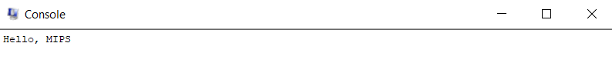

**2. Given below is a program in MIPS assembly language that computes the area of a rectangle given the width and the height.**

**The width and height are read from the standard input after prompting the user, and then the program computes the area and prints it on the standard output console.**

.data

prompt1: .asciiz "Enter the Width : "

prompt2: .asciiz "\nEnter the Height : "

area: .asciiz "\nThe Area of Rectangle is : "

.text

.globl main

main:

addi $v0,$0,4

la $a0,prompt1

syscall

addi $v0,$0,5

syscall

add $8,$0,$v0

addi $v0,$0,4

la $a0,prompt2

syscall

addi $v0,$0,5

syscall

add $9,$0,$v0

mult $8,$9

mflo $10

addi $v0,$0,4

la $a0,area

syscall

addi $v0,$0,1

add $a0,$0,$10

syscall

exit:

ori $v0,$0,10

syscall

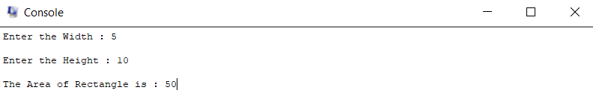

**3. Modify the above given program so that it also calculates and prints the perimeter (i.e., sum of all sides) of the rectangle.**

.data

prompt1: .asciiz "Enter the Width : "

prompt2: .asciiz "\nEnter the Height : "

area: .asciiz "\nThe Area of Rectangle is : "

perimeter: .asciiz "\n\nThe Perimeter of Rectangle is : "

.text

.globl main

main:

addi $v0,$0,4

la $a0,prompt1

syscall

addi $v0,$0,5

syscall

add $8,$0,$v0

addi $v0,$0,4

la $a0,prompt2

syscall

addi $v0,$0,5

syscall

add $9,$0,$v0

mult $8,$9

mflo $10

addi $v0,$0,4

la $a0,area

syscall

addi $v0,$0,1

add $a0,$0,$10

syscall

add $8,$8,$9

addi $10,$0,2

mult $8,$10

mflo $10

addi $v0,$0,4

la $a0,perimeter

syscall

addi $v0,$0,1

add $a0,$0,$10

syscall

exit:

ori $v0,$0,10

syscall

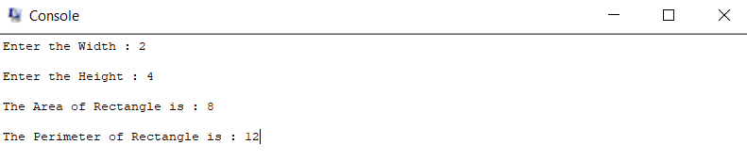

**4. For any choice of a and b, find (a+b)^2, and print the result. Also print results of each term in the expansion.**

.data

prompt1: .asciiz "Enter the A : "

prompt2: .asciiz "\nEnter the B : "

a1: .asciiz "\nA : "

b1: .asciiz "\n\nB : "

aout: .asciiz "\n\nA^2 : "

bout: .asciiz "\n\nB^2 : "

cout: .asciiz "\n\n2AB : "

finalout: .asciiz "\n\n(A+B)^2 => A^2 + B^2 + 2AB => "

.text

.globl main

main:

addi $v0,$0,4

la $a0,prompt1

syscall

addi $v0,$0,5

syscall

add $8,$0,$v0

addi $v0,$0,4

la $a0,prompt2

syscall

addi $v0,$0,5

syscall

add $9,$0,$v0

add $11,$0,$8

add $12,$0,$9

addi $v0,$0,4

la $a0,a1

syscall

addi $v0,$0,1

add $a0,$0,$11

syscall

addi $v0,$0,4

la $a0,b1

syscall

addi $v0,$0,1

add $a0,$0,$12

syscall

mult $8,$8

mflo $13

mult $9,$9

mflo $14

addi $v0,$0,4

la $a0,aout

syscall

addi $v0,$0,1

add $a0,$0,$13

syscall

addi $v0,$0,4

la $a0,bout

syscall

addi $v0,$0,1

add $a0,$0,$14

syscall

addi $15,$0,2

mult $11,$15

mflo $10

mult $10,$12

mflo $10

addi $v0,$0,4

la $a0,cout

syscall

addi $v0,$0,1

add $a0,$0,$10

syscall

add $15,$13,$14

add $15,$15,$10

addi $v0,$0,4

la $a0,finalout

syscall

addi $v0,$0,1

add $a0,$0,$15

syscall

exit:

ori $v0,$0,10

syscall

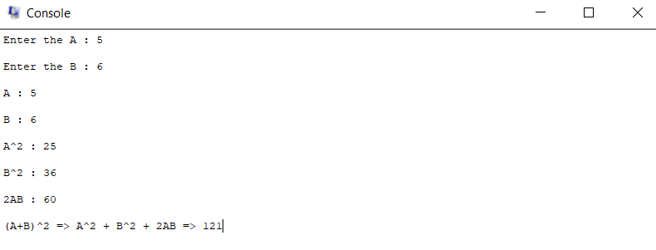

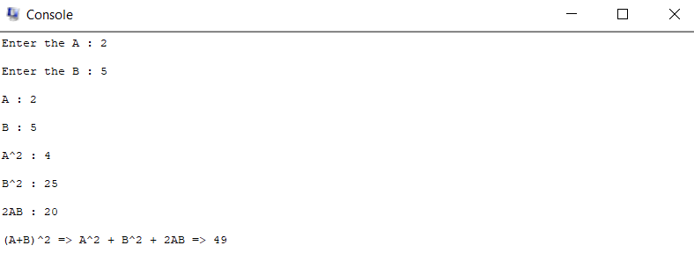

**5. Find and print the base of a triangle whose area = 6cm^2 and height is 4 cm. [Display the unit of the base].**

.data

prompt1: .asciiz "Enter the Area of Triangle : "

prompt2: .asciiz "\nEnter the Height of Triangle : "

area : .asciiz "\nArea of Triangle is : "

height: .asciiz "\n\nHeight of Triangle is : "

base: .asciiz "\n\nBase of Triangle : "

unit: .asciiz " cm"

.text

.globl main

main:

addi $v0,$0,4

la $a0,prompt1

syscall

addi $v0,$0,5

syscall

add $8,$0,$v0

addi $v0,$0,4

la $a0,prompt2

syscall

addi $v0,$0,5

syscall

add $9,$0,$v0

addi $v0,$0,4

la $a0,area

syscall

addi $v0,$0,1

add $a0,$0,$8

syscall

addi $v0,$0,4

la $a0,height

syscall

addi $v0,$0,1

add $a0,$0,$9

syscall

addi $10,$0,2

mult $10,$8

mflo $10

div $10,$9

mflo $10

addi $v0,$0,4

la $a0,base

syscall

addi $v0,$0,1

add $a0,$0,$10

syscall

addi $v0,$0,4

la $a0,unit

syscall

exit:

ori $v0,$0,10

syscall

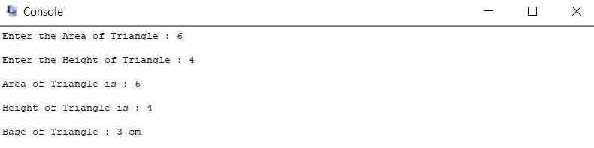

**6. A car approaching a school zone speeds up from 9 m/s to 27 m/s with constant acceleration 2 m/s2.**

**How much time is required to slow down to final velocity? [Print the result with units, Hint: v = u+at]**

.data

prompt1: .asciiz "Enter the v : "

prompt2: .asciiz "\nEnter the u : "

prompt3: .asciiz "\nEnter the a : "

v: .asciiz "\n\nv : "

u: .asciiz "\n\nu : "

a: .asciiz "\n\na : "

time: .asciiz "\n\nTime Required : "

.text

.globl main

main:

addi $v0,$0,4

la $a0,prompt1

syscall

addi $v0,$0,5

syscall

add $8,$0,$v0

addi $v0,$0,4

la $a0,prompt2

syscall

addi $v0,$0,5

syscall

add $9,$0,$v0

addi $v0,$0,4

la $a0,prompt3

syscall

addi $v0,$0,5

syscall

add $10,$0,$v0

addi $v0,$0,4

la $a0,v

syscall

addi $v0,$0,1

add $a0,$0,$8

syscall

addi $v0,$0,4

la $a0,u

syscall

addi $v0,$0,1

add $a0,$0,$9

syscall

addi $v0,$0,4

la $a0,a

syscall

addi $v0,$0,1

add $a0,$0,$10

syscall

sub $8,$8,$9

div $8,$10

mflo $8

addi $v0,$0,4

la $a0,time

syscall

addi $v0,$0,1

add $a0,$0,$8

syscall

exit:

ori $v0,$0,10

syscall

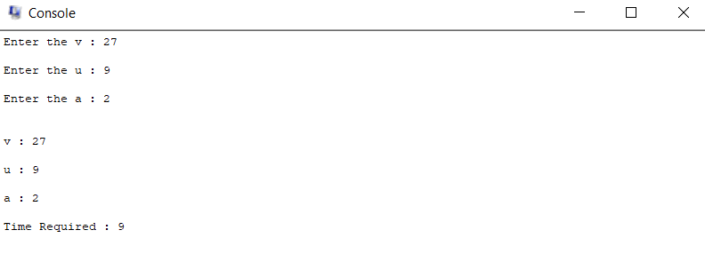

**Thankyou!!**